AI-Based Strategy Builder and Multi-Factor Confidence Scoring System for Equity Trading
¹ Jeyrenth Siva B , ¹Rokith K , ¹ Yeshwandh D , ² Dr.A.Manikandan
¹UG Student, Department of Computer Science and Engineering, Vels Institute of Science, Technology and Advanced Studies (VISTAS), Pallavaram, Chennai, India
² Professor, Department of Computer Science and Engineering, Vels Institute of Science, Technology and Advanced Studies (VISTAS), Pallavaram, Chennai, India
jeyrenthshiva@gmail.com, rrokith374@gmal.com, yeshwandh.d@gmail.com, mani.se@vistas.ac.in
Abstract—Combining machine learning with technical indicators has been reported to beat single-indicator, rule-based trading, yet most such systems hand the user only a single directional signal or one aggregate return figure. It is hard to see which factors produced a recommendation, and the strategy logic cannot be changed. We propose an explainable, configurable trading framework built from two modules. The Confidence Scanner calculates a set of independent technical and fundamental indicators for each stock and feeds them to a gradient-boosted decision tree, which returns a continuous, signed confidence score together with an explanation of each individual prediction. The Strategy Builder lets a user assemble a strategy through toggles that map onto a strict, back testable schema. It covers interdependent conditional logic, configurable stop-loss mechanisms, and position-sizing rules. Both modules run on one shared back testing engine that uses walk-forward validation, point-in-time-correct indicators, and fixed baseline comparisons. We built a working implementation on National Stock Exchange of India (NSE) equity data, consisting of a 30-indicator library, a rule-based signal reliability engine, and a full-stack web interface. On real historical data, win rates across sixteen technical signal types range from 58.1% to 100%. The results suggest that a transparent, user-configurable design can deliver competitive predictive performance while addressing the interpretability and configurability gaps, we found in the literature.
Index Terms—algorithmic trading, explainable artificial intelligence, gradient boosted trees, SHAP, technical indicators, back testing, Indian equity markets.
I. INTRODUCTION
Machine learning is now widely used in algorithmic trading, and studies of multi-indicator technical analysis report better predictive accuracy than traditional rule-based approaches [1]–[5]. One problem recurs throughout this work, though. Systems that pair machine learning with technical indicators usually deliver a single directional signal or a back tested aggregate return. They do not show why a recommendation was made, and the user cannot examine, challenge, or change the decision logic behind it. This lack of transparency discourages practitioners from adopting ML-based trading tools, and [1] names it explicitly as an unsolved problem.
Configurability is a second weak point. In existing research systems the choice and weighting of indicators are fixed inside the pipeline, so users cannot state which signals matter to them or combine conditions across several indicators and timeframes. Commercial no-code platforms for retail investors have a similar restriction: strategies are typically limited to independent conditions that cannot interact.
We propose a two-module framework that targets both gaps together. The Confidence Scanner tackles interpretability. It combines several technical indicators with a gradient-boosted decision tree and adds a game-theoretic explanation layer, so each continuous confidence score comes with a breakdown of the factors behind it. The Strategy Builder tackles configurability through a strict, user-editable strategy schema that supports interdependent conditional logic, stop-loss options, and position-sizing rules. Both modules are evaluated against fixed baselines using walk-forward validation, which limits look-ahead bias and overfitting.
The rest of the paper is organized as follows. Section II reviews related work and states the research gap. Section III presents the proposed architecture, and Section IV describes the current implementation. Section V reports and discusses the results, and Section VI concludes with future work.
II. RELATED WORK
Sukma and Namahoot [1] present a trading framework that uses machine learning to select and combine multiple technical indicators. They test eight classifier types and keep the best one; gradient boosting machines came out on top with 73.1% accuracy. We use this work as our main baseline. Even so, their system has no user-facing configuration interface, outputs a discrete trading signal instead of a continuous ranked score, and the authors themselves list better interpretability as future work.
Worasucheep [2] builds a heterogeneous ensemble of five classifiers trained on 45 technical indicators. A modified majority vote among the three most accurate classifiers produces the final call, and this outperforms buy-and-hold, the individual classifiers, and plain unweighted voting. The combination, however, happens across classifiers and not across indicators, and the evaluation covers only the Thai market.
Vismayaa et al. [3] test eleven classifiers as trading recommender systems on 293 stocks listed on the BSE. Their study shows that the approach works on Indian equities, but the output is still a discrete class and the user cannot configure anything.
Sahu et al. [4] compare five classifiers for generating long and short intraday signals on NSE data. A support vector machine performed best, at 72.41% accuracy. As in [1], a single best classifier is chosen and indicator-level signals are not combined.
Wang et al. [5] contribute a benchmark and a multi-agent framework that turns natural-language strategy descriptions into executable backtests. Their ablations indicate that reliable translation depends on checking outputs against real market data and on describing indicators in one consistent format. This directly shapes the natural-language interface we plan to add to our system. Their focus, however, is the reliability of generated code and not the design of a product for end users.
Table I places the reviewed studies next to the present work.
Ref. | Method | Config. UI | Cont. Score | Market
[1] | 8-classifier selection (GBM best) | No | No | Global
[2] | 5-classifier ensemble vote | No | No | Thailand
[3] | 11-classifier comparison | No | No | India (BSE)
[4] | 5-classifier comparison | No | No | India (NSE)
[5] | Multi-agent LLM (NL→backtest) | N/A | N/A | N/A
Proposed | GBT + SHAP, toggle-configurable | Yes | Yes | India (NSE)
TABLE I. COMPARISON OF RELATED WORK
Three gaps stand out across this literature. First, indicator selection and weighting stay inside the research pipeline in every study. Second, work on natural-language interfaces [5] and work on multi-indicator prediction [1]–[4] have developed separately from each other. Third, when signals are combined at all, it is done at the classifier level [2] or by choosing one best model [1], [4]; none of the studies learn interpretable, per-indicator attributions from backtested history. Our system is designed to close all three gaps.
III. PROPOSED SYSTEM ARCHITECTURE
Our system keeps prediction separate from execution, much like the split between alpha generation and portfolio construction in systematic trading. Model complexity goes into the Confidence Scanner, where the real predictive uncertainty lies. The Strategy Builder is deliberately deterministic and easy to inspect, because that is the layer where a user's own behavioral biases have the most influence. Fig. 1 shows the overall architecture.
A. Data Layer
Historical and live NSE equity data are ingested so that every derived indicator is point-in-time correct, meaning it can be computed using only information available at or before its own timestamp. This prevents look-ahead bias in backtesting.
B. Confidence Scanner
The Confidence Scanner computes a set of independent technical and fundamental indicators and merges them with a gradient-boosted decision tree model [6]. We chose trees over linear methods because they can capture interactions between indicators, such as a volume signal that matters only when a trend signal is also present, which an additive linear model cannot represent. Each prediction is accompanied by SHAP values [7], a game-theoretic attribution method that splits a prediction into per-indicator contributions. The module returns a continuous, signed confidence score between −100 (strongly bearish) and +100 (strongly bullish), instead of the discrete class used in earlier work [1], [3], [4].
C. Strategy Builder
In the Strategy Builder, the user sets entry conditions, a stop-loss mechanism, and position sizing through toggles. These map onto a strict, versioned schema that allows interdependent conditional logic across indicators and timeframes. The supported stop-loss types are fixed-percentage, Average True Range (ATR)-based, and swing-low-based. Every parameter is named and readable by a human by design. A natural-language interface, informed by [5], is planned as a later extension; it will only fill in this same schema and will not generate free-form logic.
D. Shared Backtesting and Validation Engine
Both modules run on one backtesting engine with walk-forward validation. A model is trained on a historical window and tested only on the next unseen window, after which the window rolls forward; this replaces a single static train/test split. The engine accounts for transaction costs and always keeps two baselines, buy-and-hold and equal-weighted indicator voting. Every result is compared against them using the Sharpe ratio, Sortino ratio, maximum drawdown, and Calmar ratio.
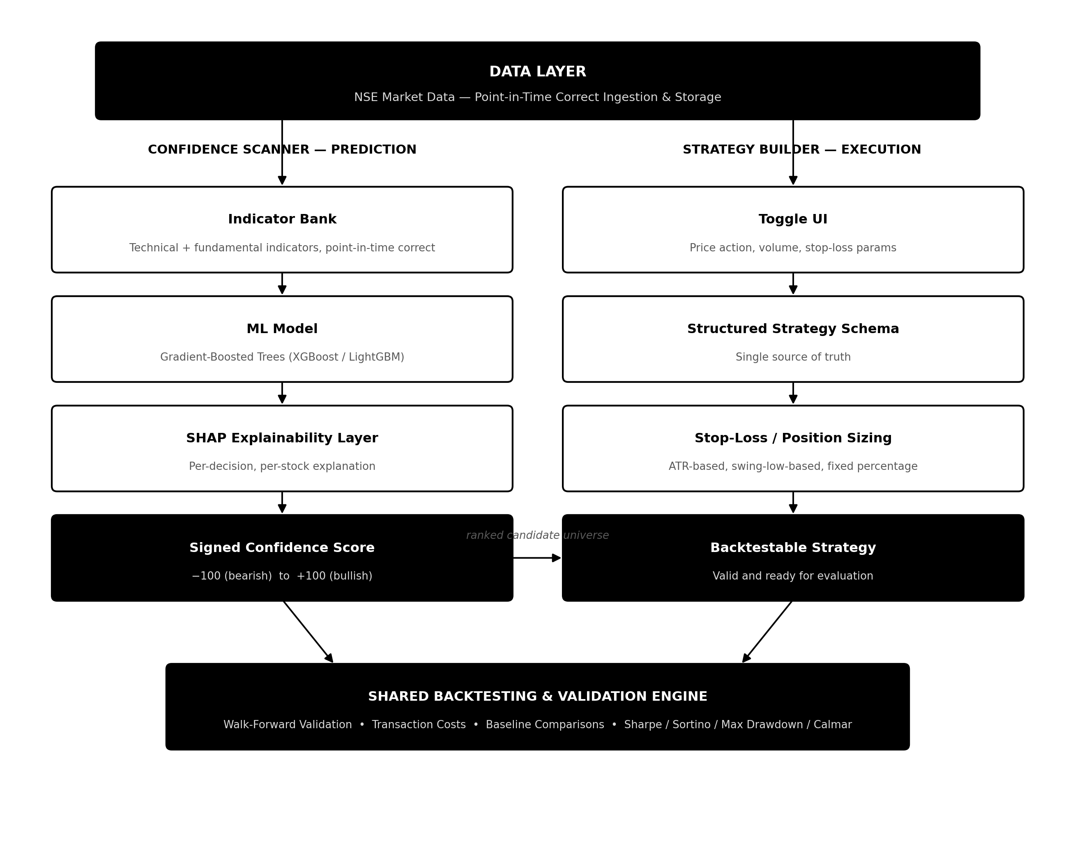
Fig. 1. Proposed system architecture.
IV. IMPLEMENTATION
We have implemented the proposed architecture in Python. The implementation has four main components.
A. Strategy Schema
The strategy configuration from Section III-C is defined as a fully typed schema written with Pydantic. It supports more than 30 indicator types across momentum, trend, volatility, volume, price-action, and fundamental categories, along with a condition tree that allows AND, OR, and NOT combinations.

B. Indicator Library
Indicator calculations are grouped by category. They form the computational base for both the Strategy Builder interface and the scoring engine described below.
C. Signal Reliability Engine
Before introducing model complexity, we wanted to validate the schema, the data pipeline, and the evaluation infrastructure. For that reason we first built a rule-based signal reliability engine as an interim step toward the gradient-boosted model of Section III-B. It detects sixteen technical signal types and scores each one by historical win rate, profit factor, maximum favorable and adverse excursion, and a composite confidence metric.
D. Web Application
The web application has a FastAPI backend and a JavaScript frontend, and it exposes both the strategy builder and the signal analyzer. It also includes a parameter-sensitivity visualization that recomputes a signal's historical win rate over its full parameter range as the user interacts with it.
V. RESULTS AND DISCUSSION
A. Results
We evaluated the signal reliability engine on two years of daily historical data for Reliance Industries Limited (NSE: RELIANCE). Table II and Fig. 2 give the win rate, sample size, and average return for a representative subset of the signal types.
Signal | Win Rate | n | Avg. Return
MACD Bullish Crossover | 58.1% | 31 | +0.9%
RSI Oversold Reversal | 77.8% | 18 | +1.8%
Supertrend Flip | 85.7% | 28 | +2.1%
Volume Breakout (2.0×) | 100.0% | 17 | +4.2%
TABLE II. SIGNAL RELIABILITY RESULTS (RELIANCE, 2-YEAR DAILY)
We used the parameter-sensitivity visualization to study the RSI Oversold Reversal signal. Moving the oversold threshold from its default of 30 up to 41 raised the observed win rate from 77.8% to 88.5%, across 26 occurrences in the same dataset. For the intraday time-of-day signals, tested on 15-minute data, Morning Breakout events won 72.7% of the time (33 events) and Afternoon Reversal events won 75.0% (8 events).
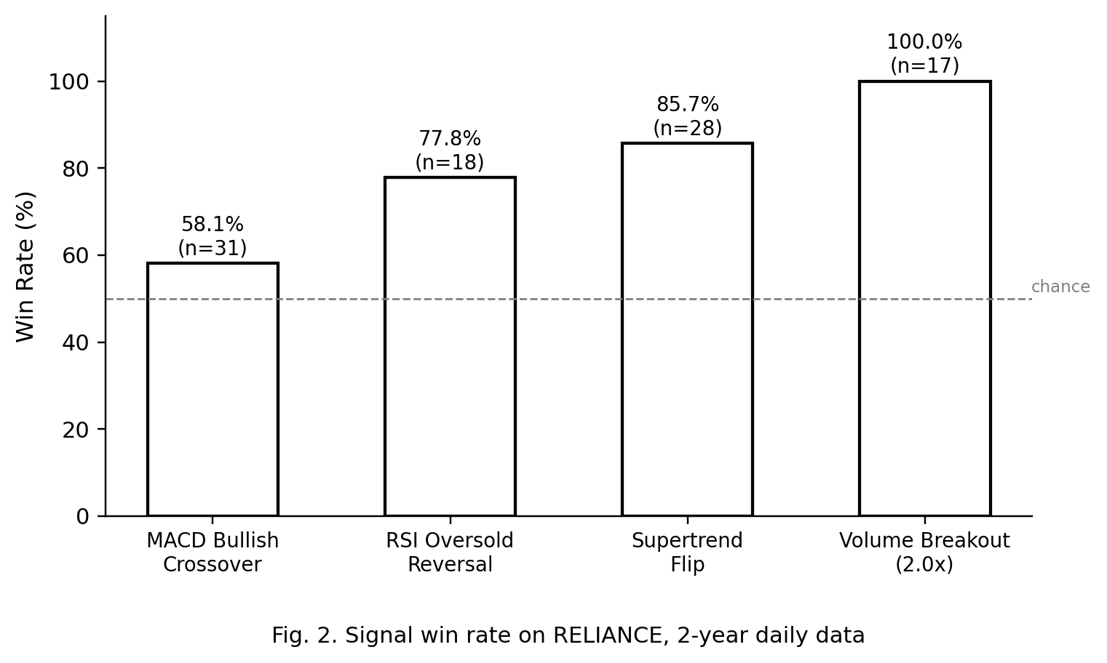
B. Discussion
Win rates on this single instrument range from 58.1% to 100.0%, so technical signals clearly differ in how much predictive value they carry. This supports the main premise behind the Confidence Scanner: a model that can learn how much each signal matters in a given context is expected to do better than both the equal-weighted baseline and the current rule-based scorer. The rule-based engine has one main weakness. It scores every signal on its own, so it cannot capture cases where signals occurring together are worth more than either one alone. That is the weakness the planned gradient-boosted model is meant to fix, and the present results will serve as the baseline for measuring the improvement.
The parameter-sensitivity result shows why empirical parameter search is useful, but it also calls for caution. An optimum found on one instrument in one period may simply reflect noise specific to that history. Until walk-forward validation on a wider stock universe and several non-overlapping periods confirms it, it should be treated as a possible backtest artifact rather than a real improvement. The intraday results rest on small samples (33 and 8 events), so we regard them as preliminary.
VI. CONCLUSION AND FUTURE WORK
This paper presented a two-module trading framework aimed at the interpretability and configurability gaps in the multi-indicator algorithmic trading literature. We built a working implementation with a typed strategy schema, a 30-indicator library, a rule-based signal reliability engine, and a full-stack web interface, and tested it on real NSE historical data. Win rates across sixteen technical signal types ranged from 58.1% to 100%, and interactive sensitivity analysis produced one demonstrated case of empirical parameter improvement.
We see four directions for future work. First, we will replace the rule-based scorer with the gradient-boosted tree and SHAP-based Confidence Scanner of Section III-B and benchmark it under walk-forward validation against the results reported here, as well as against the equal-weighted and buy-and-hold baselines. Second, we will add a constrained natural-language interface to the Strategy Builder, informed by [5]. Third, we will extend the system to options trading, limited to the NSE futures-and-options-eligible universe, with premium-based position sizing and options-specific cost modeling. Fourth, we will run live paper trading to measure the gap between backtested and live performance before any use of live capital is considered.
REFERENCES
[1] N. Sukma and C. S. Namahoot, “An Algorithmic Trading Approach Merging Machine Learning With Multi-Indicator Strategies for Optimal Performance,” IEEE Access, vol. 12, pp. 188154–188173, 2024.
[2] C. Worasucheep, “Ensemble Classifier for Stock Trading Recommendation,” Applied Artificial Intelligence, vol. 36, no. 1, art. 2001178, 2021.
[3] V. Vismayaa, K. R. Pooja, A. Alekhya, C. N. Malavika, B. B. Nair, and P. N. Kumar, “Classifier Based Stock Trading Recommender Systems for Indian Stocks: An Empirical Evaluation,” Computational Economics, vol. 55, no. 3, pp. 901–923, 2020.
[4] S. K. Sahu, A. S. Mokhade, P. K. Agrawal, and K. Kalyani, “Utilizing Supervised Machine Learning and Technical Indicators for Quantitative Trading to Improve Stock Market Trading Decisions,” SN Computer Science, vol. 6, art. 498, 2025.
[5] Z. Wang et al., “BacktestBench: Benchmarking Large Language Models for Automated Quantitative Strategy Backtesting,” arXiv:2605.17937, 2026.
[6] J. H. Friedman, “Greedy function approximation: A gradient boosting machine,” Annals of Statistics, vol. 29, no. 5, pp. 1189–1232, 2001.
[7] S. M. Lundberg and S.-I. Lee, “A unified approach to interpreting model predictions,” in Proc. 31st Int. Conf. Neural Information Processing Systems (NeurIPS), 2017, pp. 4768–4777.

